2018 GYN 中國 陳尚文
Case 02: Vulva cancer: Left major labia tumor (4cm 或 2.5cm) with right inguinal LN 1#
*病人拒絕任何的手術請問你要如何做治療？(我回答 CCRT)
■ RT dose? Field? (考官強調 LN 不用那麼保守可以給到70 Gy)
■ 問了GOG205 的結果pCR 多少 (50%), 所以可以積極點給到70Gy
■ RT 擺位跟 simulation 要注意什麼？(frog leg, bolus, TLD)
A. Vulvar ca treatment:
stage I-II OP為主
stage III-IV以 neoadj-CRT +/- organ sparing surgery 為主
若患者拒絕手術，就以definitive CRT治療
-RT field: 根據Nancy Lee
CTV-H to 60-70 Gy: primary tumor + remaining un-involved vulva and adjacent soft tissue+LAP
CTV-L to 45-50.4 Gy: pelvic and bilateral inguino-femoral LN regions
(pelvic including common/int./ext. iliac+ pre-sacral if vaginal involvement
+ peri-rectal if rectal/anal invasion)
**根據GOG 37發現inguinal LAP(+) pelvic RT vs LND有 OS benefit
-concurrent with weekly cisplatin
B. GOG 205: 57.6Gy/32frx with concurrent C40, cCR: 64%, pCR: 50%.

2011丁禮莉醫師(不再當考官了)
1. 請寫出ASCUS, LGSIL, HGSIL, LOOP的全名
2. 上述前三者發生要如何處理，第四個在什麼情況下會使用?
 |  | management
ASCUS | atypical squamous cell of uncertain significance  , 2/3 resolve spontaneously | repeat Pap in 6 months
LGSIL | low-grade squamous intraepithelial lesion (mild dysplasia/CIN 1)  , 1/2 resolve spontaneously | repeat Pap in 6 months
HGSIL | High-grade squamous intraepithelial lesion(severe dysplasia/CIN 2/3/CIS), 1/3 resolve sponteneously | colposcopy with bx
LOOP | Loop electrosurgical excision procedure (LEEP)  Cone biopsy: 用於診斷or trx for pre-cancer lesion and fertility-preserving early ca trx
3. 甚麼癌症與DES有關?
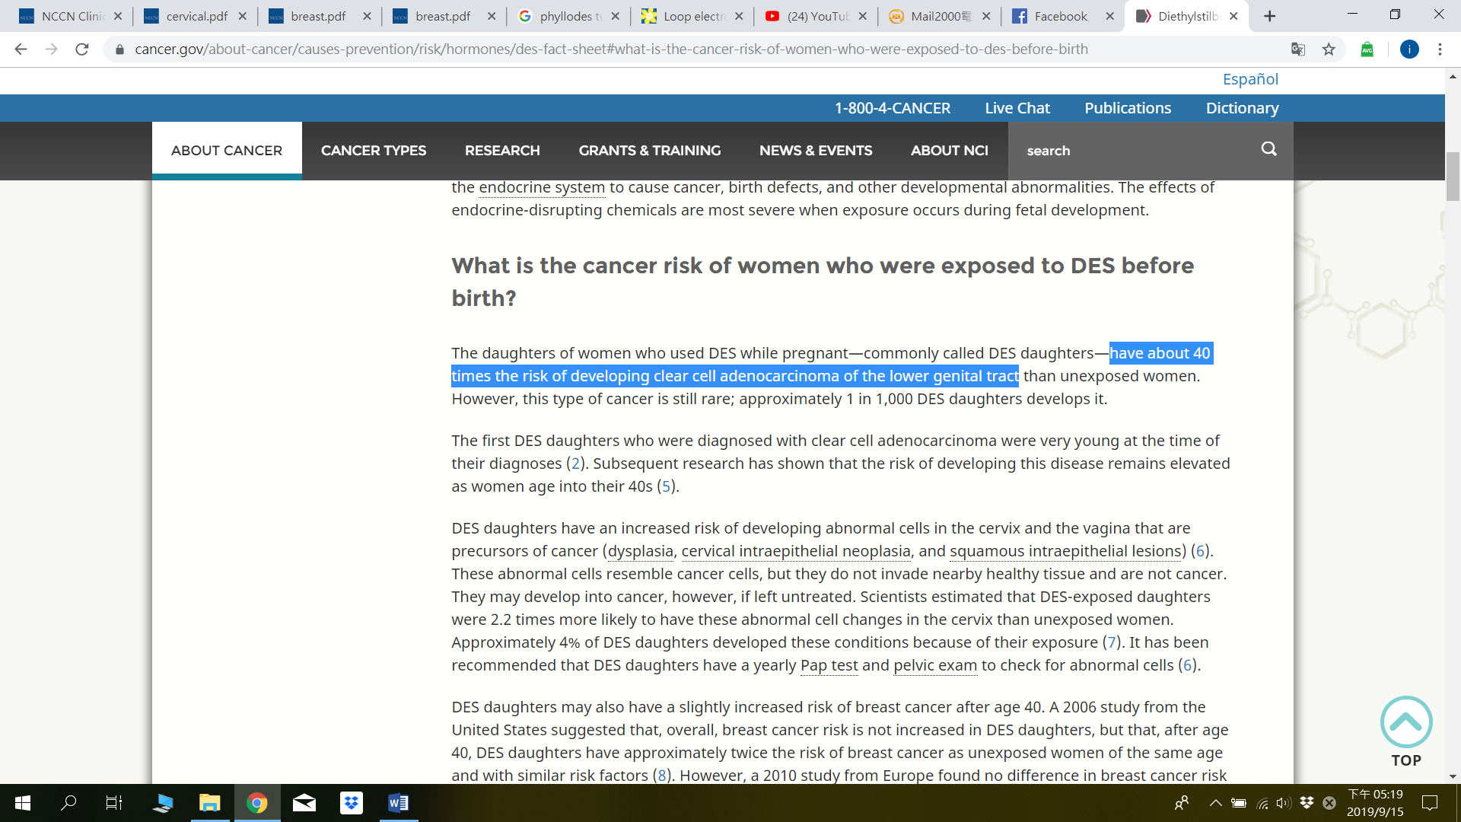
4. 子宮頸癌stage I有哪些條件要考慮做術後的RT? 哪些條件要做術後的CCRT?
5. 除了做pelvic RT之外有無其他的治療方式?
6. 有無做brachytherapy，如何決定A點, B點, bladder及rectum tolerance dose?實際治療給予的劑量、次數、頻率?
7. 健保給付健康人以及子宮頸癌病人抹片篩檢的頻率如何?
這個我看半天有點不明白，結論應該是建議至少3年一次，但給付是每年一次。
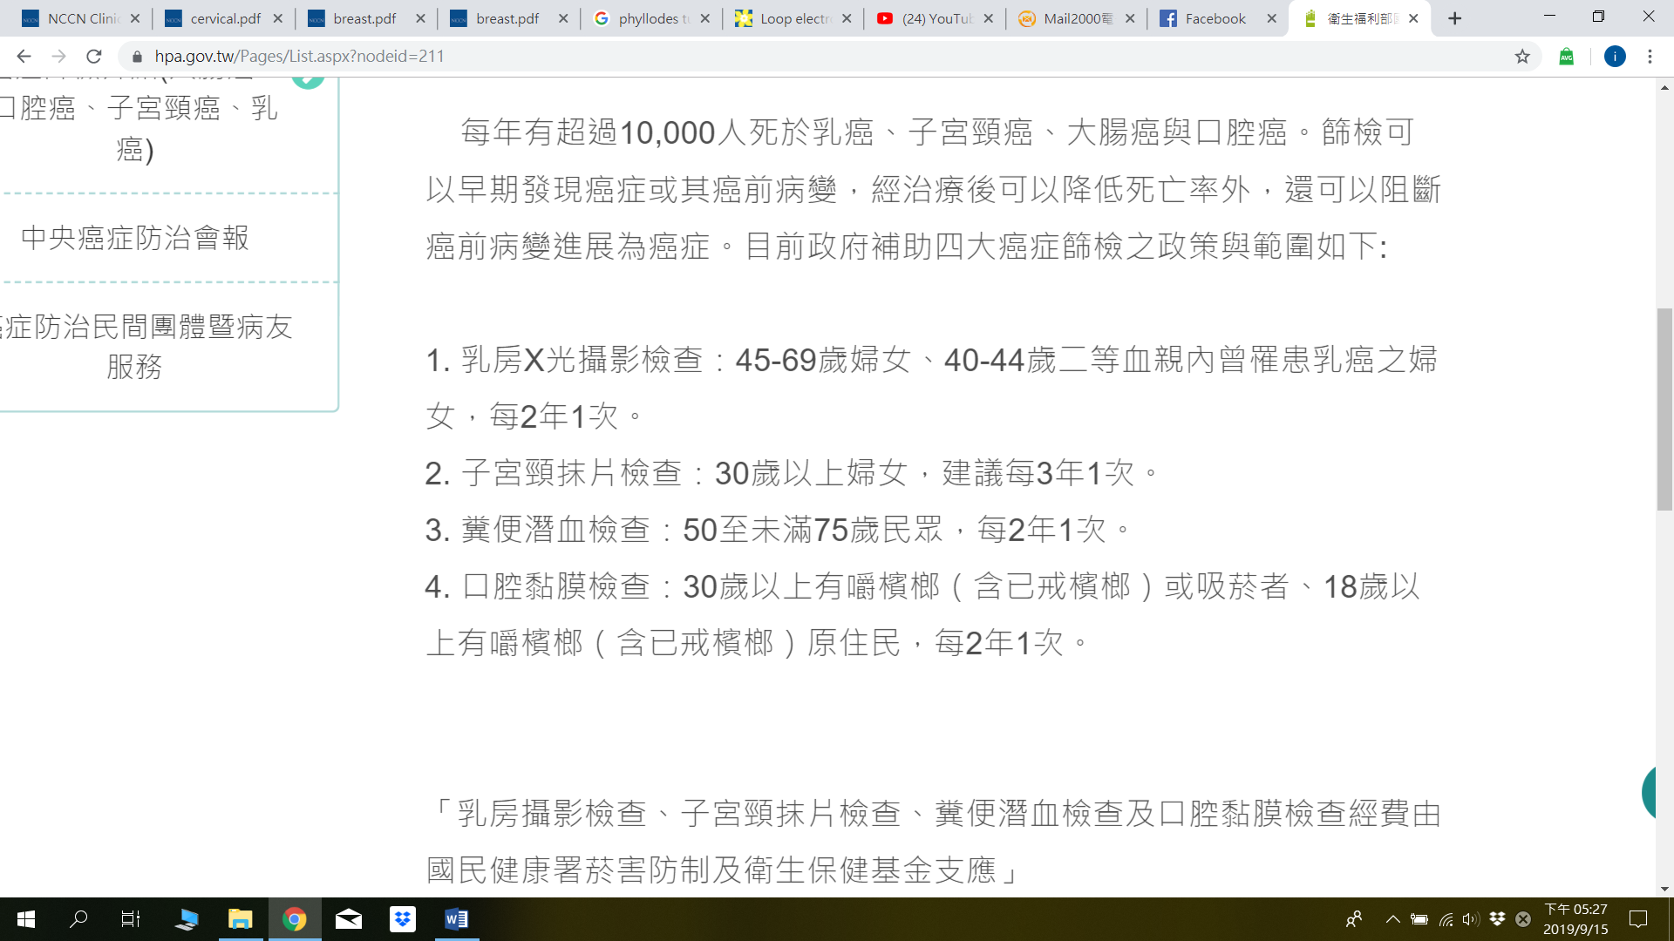
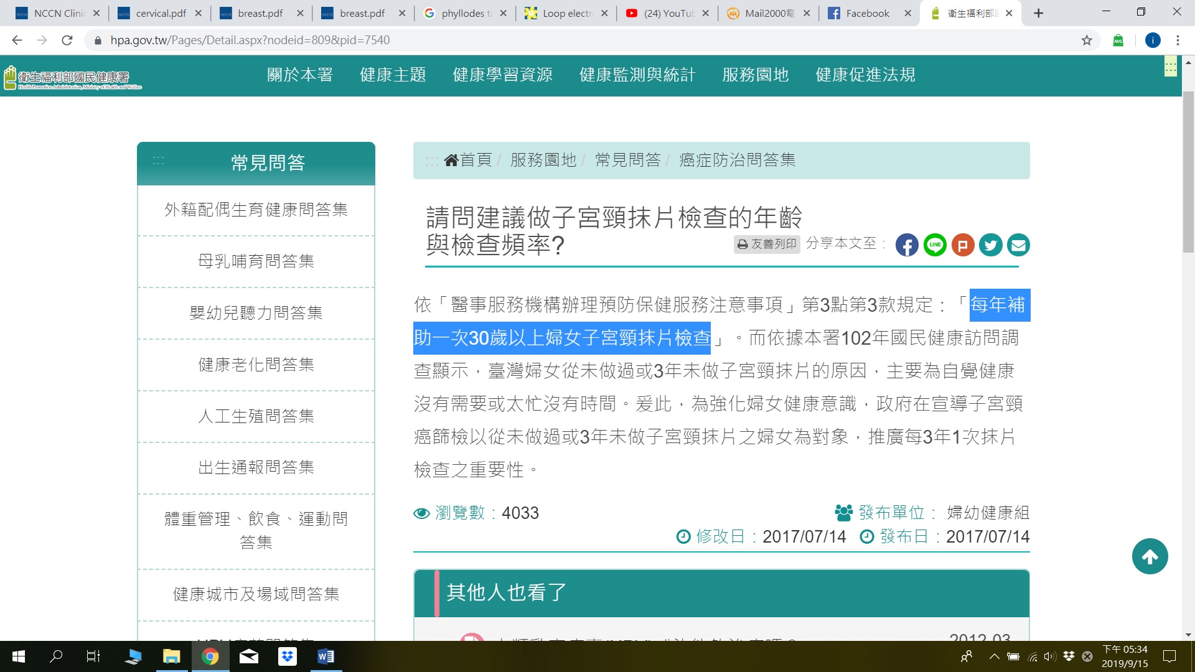
8. 確定診斷病人後健保如何給付子宮頸癌抹片的次數?(就是要問paraaortic LN node的照法及evidence-based)? 如果病人侵犯到lower vagina要注意照哪裡? (這啥@@)
9. Vagina cancer的risk factor有哪些?
Low sociocultural status
HPV infection (75%)
History of STD
History of CIN or cervical cancer
10-50% VAIN or invasive vaginal cancer; from cervical disease to vaginal cancer: average 14 years
A 5-year period to distinguish recurrent disease or new primary vaginal cancer
Hysterectomy at an early age
60% patients had prior hysterectomy
Immunosuppression
Exposure to diethylstilbestrol (DES)
Smoking
Prior pelvic radiation

10. 甚麼樣的病人可以下vagina cancer的診斷?(要排除cervical ca and vulvar ca history)
11. 陰道癌治療的耐受性有何差別(分陰道的部位來說明)?
越上段 tolerance越佳: upper <120 Gy, mid <80-90 Gy, lower < 60-70Gy
12. Vulvar cancer的risk factor有哪些?
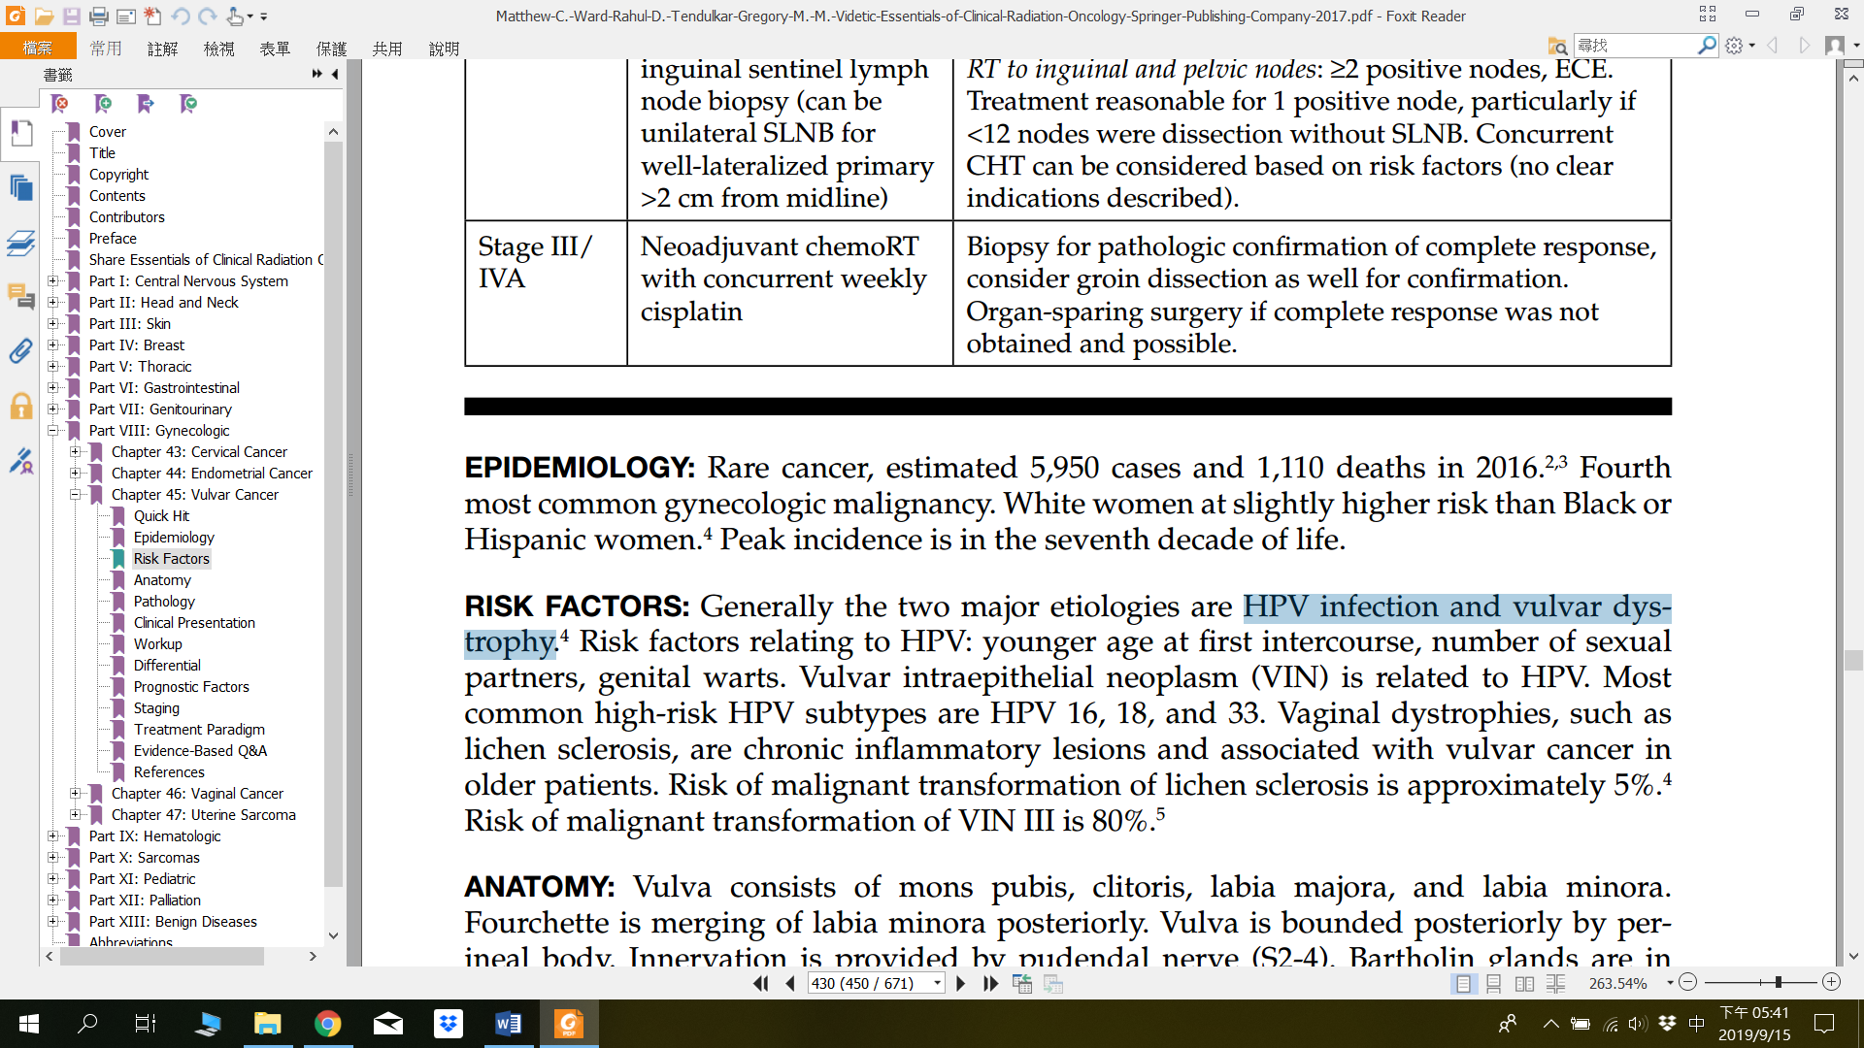
Risk factors
Age
HPV infection
Smoking
Inflammatory condition of vulva
Lichen sclerosus
Immunodeficiency

2009 丁禮莉醫師(不再當考官了)
1.Ovarian cancer的risk factor?
基因相關BRACA1及BRCA2有多少比例的病人會有卵巢癌?
prognostic factors? (以上請參照EBM p358-359)
-Risk factors: family history, nulliparity, first parity >35y/o, infertility, early menarche, late menopause,
ovulation-inducing drug, hormone replacement therapy, obesity, endometriosis, smoking
每一本書寫的都不太一樣^^” | Breast ca. | Ovarian ca.
BRCA-1 | 60-80% | 40-45% (30-50%)
BRCA-2 | 50-60% | 18-25%(10-20%)
-Prognostic factor: stage, grade, residual volume of disease, >65y/o, pre-OP ascites(+),
CA-125在CT後仍增高or Nidar >20U/ml
2.Ovarian cancer目前治療方式?
手術 只有stage IA/IB, G1可OBS, 其他都CT with carboplatin + paclitaxel*3-6 cycles
RT role? 硬要做的話要怎麼做?
目前NCCN guideline上唯二出現RT的地方(for involved field RT with 45-60 Gy)
a. malignant sex cord stromal tumor: non-fertility desired stage II-IV
術後adj platinum-based CT or RT for limited disease
b. palliative RT for symptomatic control in patient with recurrent disease
Whole abdomen RT as consolidation目前效果不確定, 30Gy in 1.2-1.5Gy/fx
+/- para-aortic or pelvic boost to 45Gy
Normal tissue constraints (WART: shield kidney after 15Gy; shield liver after 25Gy)

3.Vagina Ca stage II病人定義，病人如何治療？
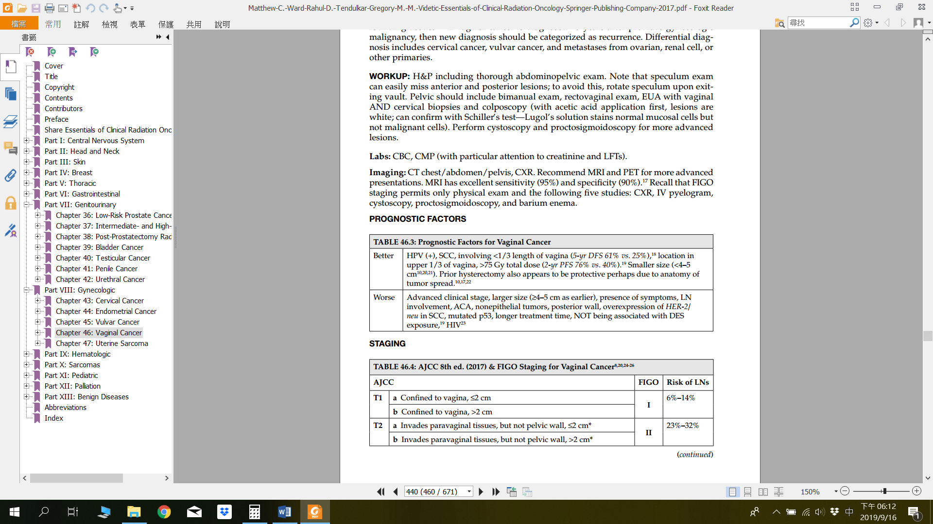
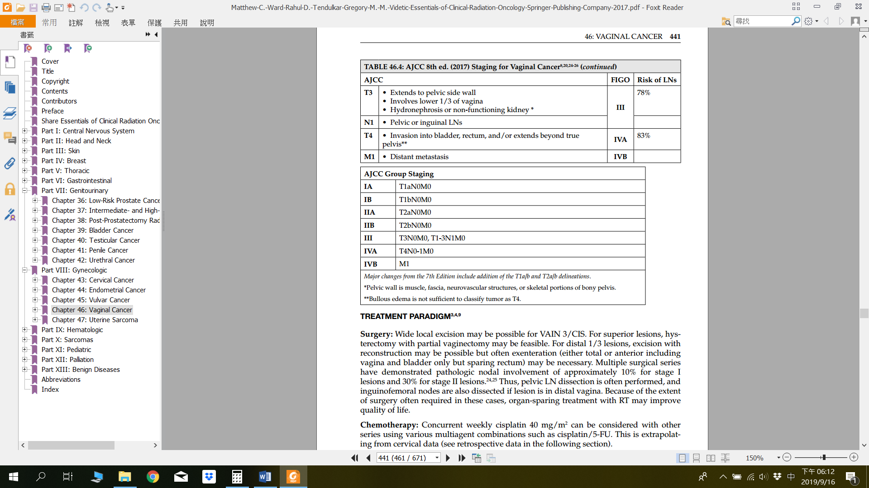
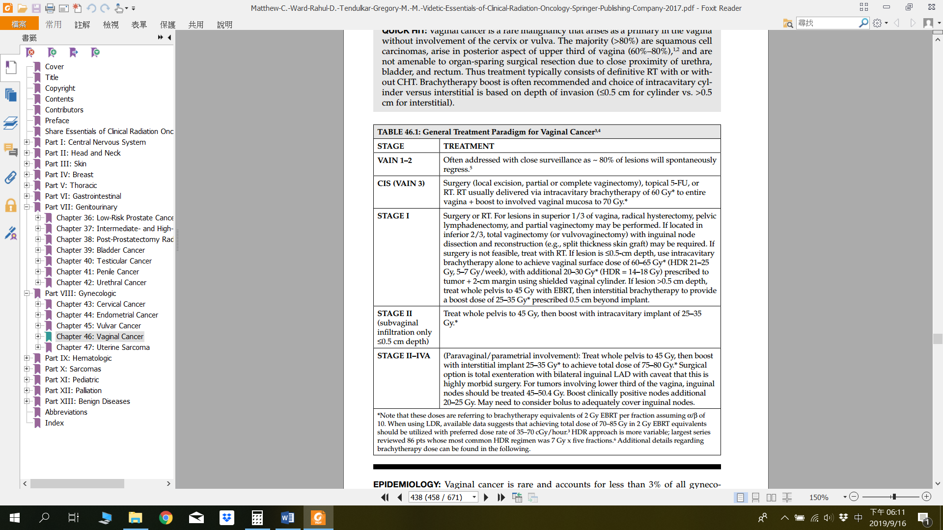
基本上除了CIS and stage I以手術為主，其他都是以EBRT+brachy+/-CT為主要治療
*例外以手術優先的indication: fistula(+), clear cell adenocarcinoma, melanoma, sacroma
4.Vaginal cancer的risk factor? 各stage的LN metastatic risk ?
5.Vagina部位對於RT tolerance的不同(同上)
6.DES造成clear cell adenocarcinoma, 除了vagina外就是cervix (同上)
7.Vulva cancer的risk factor? 尤其要知道HPV type (同上)
最常involve的LN group superficial inguinal, deep inguinal or femoral
8.Vulva cancer的治療?
有三張flow chart背出來就對了, 特別注意要記得分lateral lesion及central lesion的不同
還有primary 做完radial WLE後要做RT的indication LVI, depth >5mm, close margin定義為<8mm
9. Vulva Ca的病人什麼時候需要做二側的inguinal lymph node dissection
我只找到離中軸>1cm且cN0對策機率很低，但沒找到雙側inguinal dissection的indication
(不過我來不及仔細看NCCN拉^^”)
10. Vulva Ca侵犯深度和lymph node metastases比例的關係(這題也太…OOXX)
Stage | Depth of invasion | LN meta risk
Stage IA | <1mm | 5% (2.6)
 | 1-3mm | 10%(8.9-18.6%)
 | 3-5mm | 20%
 | >5mm depth or size>2cm | 40%
Stage III | - | 30-80%
Stage IV | - | 80-100%

11. Vulva cancer 的RT technique → 我是用2D的做法回答, photon照射的範圍, inguinal 要用electron boost….

